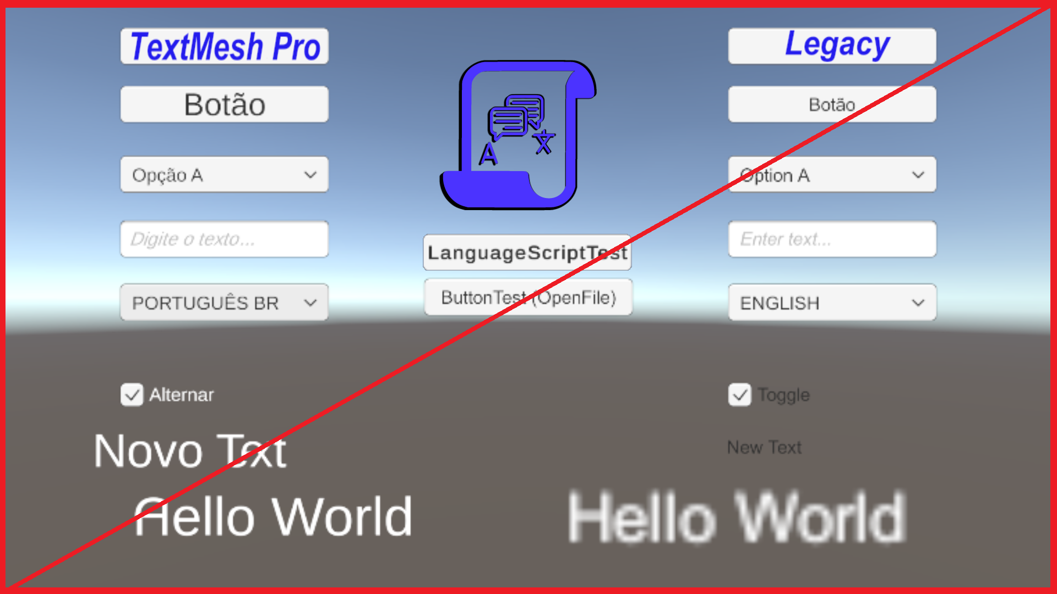
Language

Documentation
_____

Creator: Lucas Gomes Cecchini
Online Name: AGAMENOM

Overview
This document will help you to use Assets Language for Unity.
With it you can translate your game into several languages, automatic selection of languages (if you have a file available) and a simple text file to interpret, making it possible for anyone to translate the game into a new language.

Instructions
You can get more information from the Playlist on YouTube: https://youtube.com/playlist?list=PL5hnfx09yM4JkAyxrZWaFjhO3NMWxP_1F

